 





|  |  |  |  |
| --- | --- | --- | --- |
|  |  |  |  |
|  |  | ◻  ◻  ◻  ◻  ◻  ◻ |  |
|  |  | ◻  ◻  ◻  ◻  ◻  ◻ |  |
|  |  | ◻  ◻  ◻  ◻  ◻  ◻ |  |

|  |  |  |  |
| --- | --- | --- | --- |
|  |  |  |  |
|  |  | ◻  ◻  ◻  ◻  ◻  ◻ |  |
|  |  | ◻  ◻  ◻  ◻  ◻  ◻ |  |
|  |  | ◻  ◻  ◻  ◻  ◻  ◻ |  |

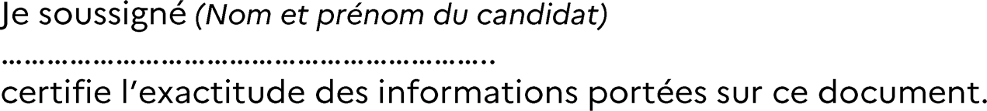

Attestation à envoyer par mail avant le 21 octobre 2024 16H à l’adresse [dexco@ac-noumea.nc](mailto:dexco@ac-noumea.nc)









    
    
   
            
        